Pair Programming 3 Turn In

Name: _____Matthew Krahel _________ Username: _______C1010B11_________

Partner name: _______Blake Hodges___________ Partner username: ____C1010B06________

_X_ I certify that my partner did work with me on these pair programming activities. Comment if needed here:

SCORE: ____________ (to be filled in by instructor)

3a (2 points)

**[/*File: pp3a.cpp**

**\* Author: Matthew Krahel and Blake Hodges**

**\* This program takes the users inputted hours and outputs**

**\* the salary based on overtime rules and pay rates**

**\*/**

**// Identifying the libraries and namespaces used in this program**

**#include <iostream>**

**using namespace std;**

**// Begin Main Function**

**int main()**

**{**

**// Declare the variable**

**double hours;**

**double rate;**

**double salary;**

**//To display display 2 decimals**

**cout.setf(ios::fixed);**

**cout.setf(ios::showpoint);**

**cout.precision(2);**

**do{**

**// Request hours from user**

**cout << "Enter hours (0 to end): ";**

**//Applying the users inputted hours**

**cin >> hours;**

**//Repeat hours to user**

**cout << "Hours entered: " << hours << "\n";**

**if (hours > 0){**

**// Request rate from user**

**cout << "Enter rate: ";**

**//Applying the users inputted rate**

**cin >> rate;**

**//Repeat rate to user**

**cout << "Rate entered: " << rate << "\n";**

**//Calculate Salary based on hours and overtime**

**if ( hours <= 40 ) {**

**salary = hours * rate;**

**}**

**else {**

**salary = 40 * rate + (hours - 40) * rate * 1.5;**

**}**

**//Output the salary**

**cout << "Salary: $" << salary << "\n";**

**}**

**else { break; }**

**} while (hours > 0);**

**return( 0 );**

**}**

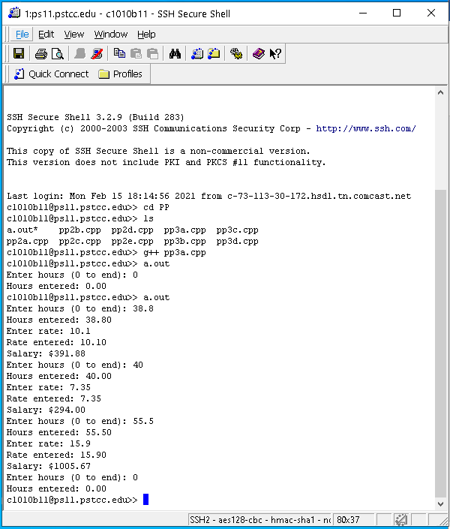3b (2 points)

**/*File: pp3b.cpp**

**\* Author: Matthew Krahel and Blake Hodges**

**\* This program takes the users inputted number**

**\* and outputs a table of values for a base raised**

**\* to each exponent up to the inputted number**

**\*/**

**// Identifying the libraries and namespaces used in this program**

**#include <iostream>**

**using namespace std;**

**// Begin Main Function**

**int main()**

**{**

**// Declare the variable**

**int maxExponent;**

**int sum = 1;**

**int base = 2; //the base of the exponent**

**// Request number from user**

**cout << "Enter n: ";**

**//Applying the users inputted number**

**cin >> maxExponent;**

**for (int exponent = 0; exponent <= maxExponent; exponent++)**

**{**

**//Display exponent and calculate equivalent**

**cout << exponent << "\t \t" << sum << "\n";**

**//Apply the next exponent to sum**

**sum = sum * base;**

**}**

**return( 0 );**

**}**

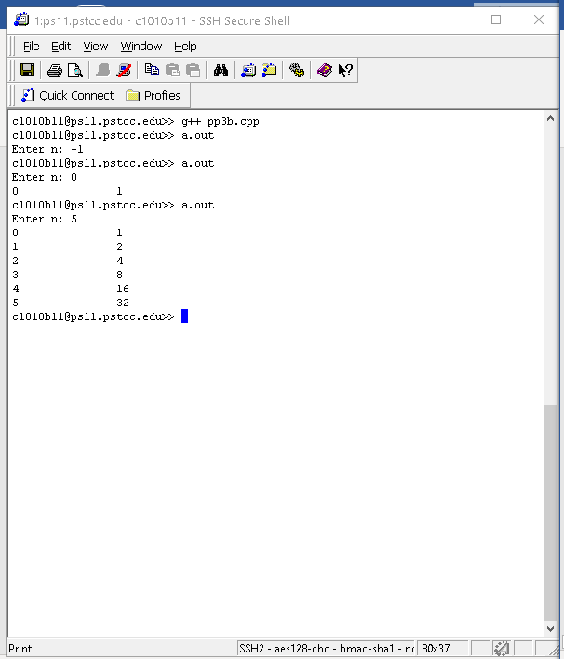3c (3points)

**/*File: pp3c.cpp**

**\* Author: Matthew Krahel and Blake Hodges**

**\* This program takes the users inputted number**

**\* and outputs the factorial total**

**\*/**

**// Identifying the libraries and namespaces used in this program**

**#include <iostream>**

**using namespace std;**

**// Begin Main Function**

**int main()**

**{**

**// Declare the variable**

**int value;**

**double sum = 1;**

**int initialValue;**

**// Request number from user**

**cout << "Enter n: ";**

**// Applying the users inputted number**

**cin >> value;**

**initialValue = value;**

**//Set the precision for larger values**

**if (value >= 20){**

**cout.setf(ios::fixed);**

**cout.precision(0);**

**}**

**while (value > 0)**

**{**

**// Multiply current sum by current value**

**sum = sum * value;**

**// Reduce the value by one**

**value--;**

**}**

**// Output the results**

**cout << initialValue << "! is " << sum << "\n";**

**return( 0 );**

**}**

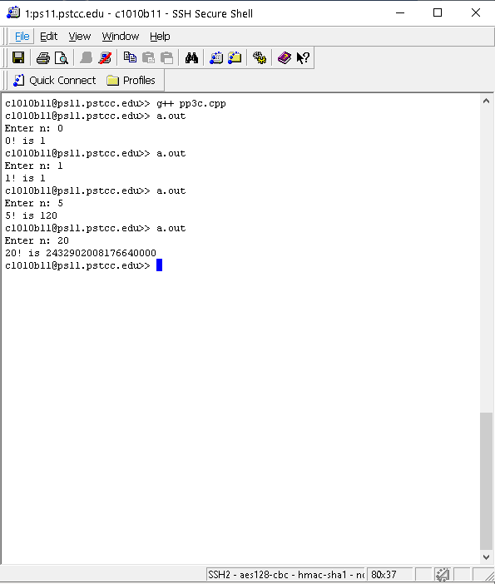3d (3 points)

**/*File: pp3d.cpp**

**\* Author: Matthew Krahel and Blake Hodges**

**\* This program outputs a menu of flooring**

**\* gets a choice from the user and outputs**

**\* the users choice and message**

**\*/**

**// Identifying the libraries and namespaces used in this program**

**#include <iostream>**

**using namespace std;**

**// Begin Main Function**

**int main()**

**{**

**// Declare the variable**

**char floorChoice;**

**int userQuit = 1;**

**do{**

**// Produce the menu for the user**

**cout << "H \t hardwood \n" << "L \t laminate \n" << "E \t engineered hardwood \n" << "Q \t quit \n";**

**// Request the user's choice**

**cout << "choice: ";**

**cin >> floorChoice;**

**switch ( floorChoice ) {**

**case 'H': case 'h':**

**cout << "Hardwood, excellent choice!\n";**

**break;**

**case 'L': case 'l':**

**cout << "Laminate, always a great value!\n";**

**break;**

**case 'E': case 'e':**

**cout << "Engineered Hardwood, definitely easy to clean!\n";**

**break;**

**case 'Q': case 'q':**

**cout << "Exiting program\n";**

**userQuit = 0;**

**break;**

**default:**

**cout << "Invalid Flooring choice: " << floorChoice << ".\n";**

**}**

**}while (userQuit > 0);**

**}**

